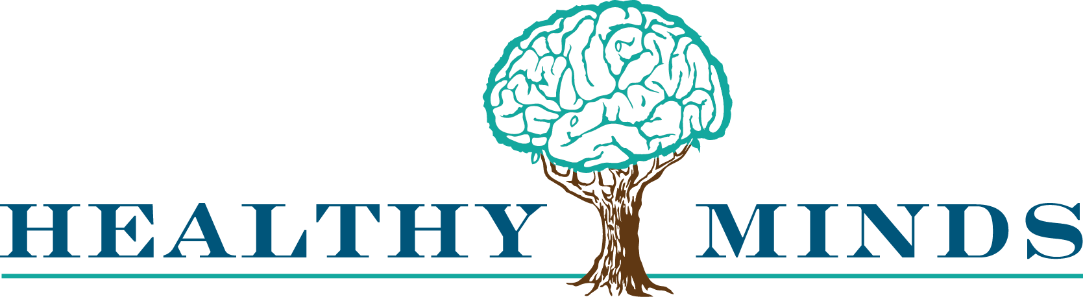

Healthy Minds Announces New, Holistic Addiction Treatment Program
A Dire Problem In Las Vegas, Substance Use Disorders Are Treatable

Las Vegas, Nevada, May 15, 2018 – Recognizing a dire community need, Healthy Minds is announcing the launch of its new Substance Use Disorder (SUD) program. Spearheaded by Melissa Paller, LCSW, Healthy Minds’ Clinical Director, the program aims to take a holistic, multidisciplinary approach to addiction treatment, by offering intensive outpatient, outpatient, and early intervention services.

Paller says Healthy Minds’ SUD program is unique to the area. “We feature a ‘co-occurring enhanced facility,’ meaning we have dually-licensed staff in-house to treat both substance abuse and mental health disorders, or what is described as co-occurring disorders. Unlike many providing agencies, in addition to therapists and psychologists, we also have psychiatrists on staff rather than contracted out, so we can treat our patients collaboratively across multiple disciplines in a co-occurring enhanced facility.”

Paller had many years of experience running substance abuse treatment programs in Idaho prior to joining the Healthy Minds team in 2012. She soon noticed opportunities for significant improvements in the ways that substance abuse was being handled in Las Vegas.

“Our jails and emergency rooms are being used as detox centers by tens of thousands of people each year, despite the fact that they’re neither designed nor equipped to handle that task,” says Paller. “These are people in need of immediate treatment upon being released from those facilities - very specialized treatment from a team of qualified medical experts.”

Additionally, the Healthy Minds team has documented that 68% of the DFS children they serve through their child & adolescent mental health programs have parents with substance abuse issues. The children’s mental health problems often stem from their parents’ addictions. To better serve these children, Healthy Minds aims to operate holistically, coordinating the treatment of the entire family under one roof while utilizing a multi-disciplinary, team-based approach.

Paller makes it clear that Healthy Minds’ SUD program will provide support for anyone suffering from a co-occuring disorder, regardless of their socioeconomic circumstances. The program accepts various insurances, Medicaid, cash, and has a sliding scale fee schedule for those who are uninsured. They are committed to working with any patient to help them in obtaining needed treatment, and are also able to offer same-day admittance into the program to expedite treatment engagement.

Healthy Minds’ SUD program is Drug Court approved, as well as being SAPTA certified.

Paller adds, “We created our SUD program with one question in mind: if we could design an addiction treatment program best equipped to make a positive impact on the problems we face here in Southern Nevada, what would that program look like? That’s what we’ve created, and we look forward to documenting our results so we can continuously improve outcomes for our patients while serving as a model for other addiction treatment programs throughout the United States.”

###

About Healthy Minds:
Healthy Minds is Las Vegas’s and Southern Nevada’s premier mental health provider. Comprised of a diverse group of Las Vegas’s top mental health experts (psychiatrists, psychologists, neuropsychologists, clinical social workers and marriage and family therapists), Healthy Minds takes a team-based approach to mental health care, and has both state and national recognition for our results. Since its founding in 2010, Healthy Minds has specialized in child & adolescent mental health care services. In 2018, recognizing a dire community need, Healthy Minds launched a holistic Substance Use Disorder (SUD) program.

For more information:
Contact: Melissa Paller
Phone: 702-622-2491
Email: melissapaller@healthymindslv.com
Media package: https://www.healthymindslv.com/media-package/

